MongoDB is developed by 10Gen after the company name renamed as mongoDB.

MongoDB is use to structure, unstarucured and semi structured database storage platform. Which store data in JSON form.

MongoDB is open source platform, document oriented no sql database management system.

MongoDB is name comes form the Hu**mongo**us.



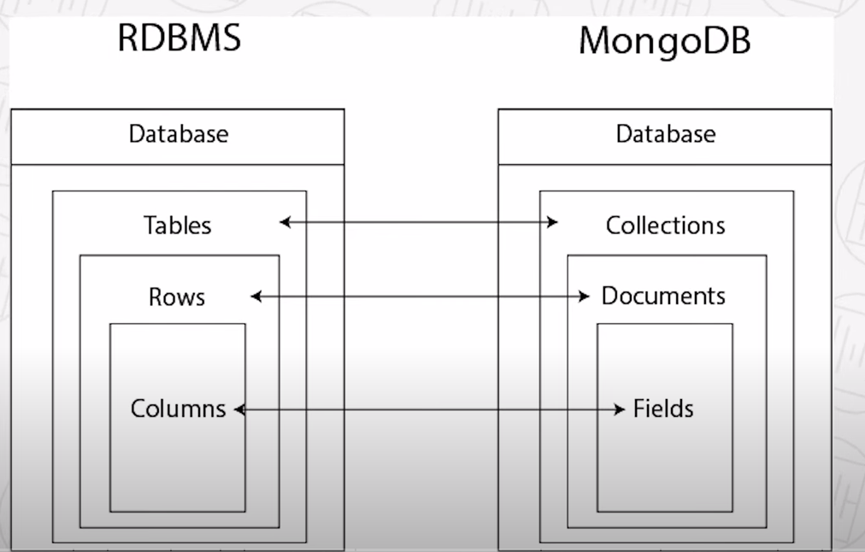

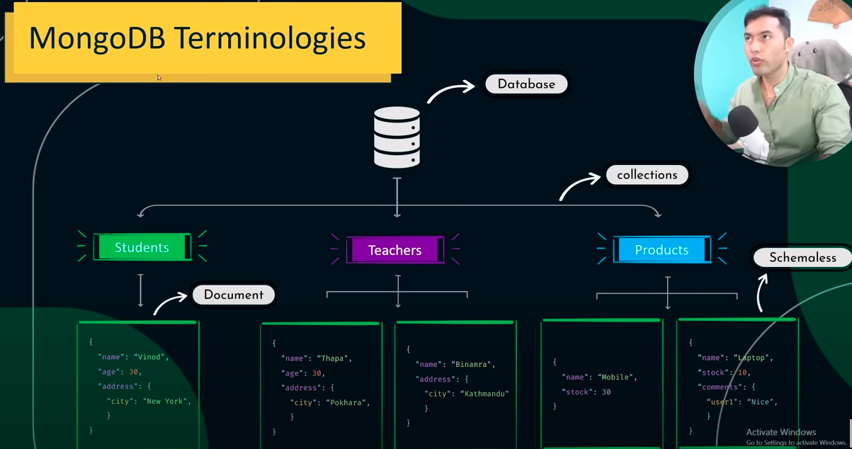



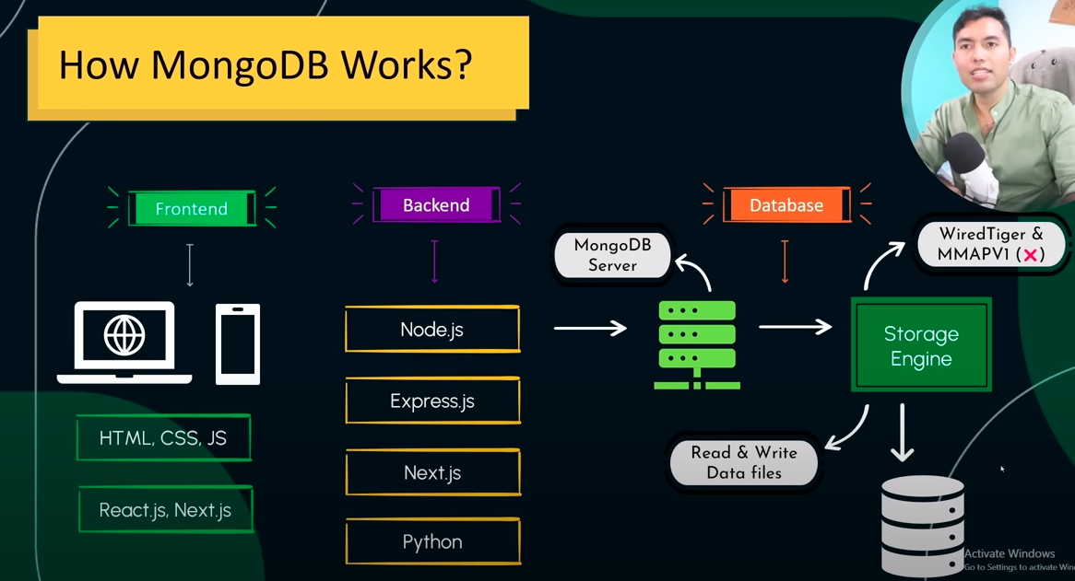



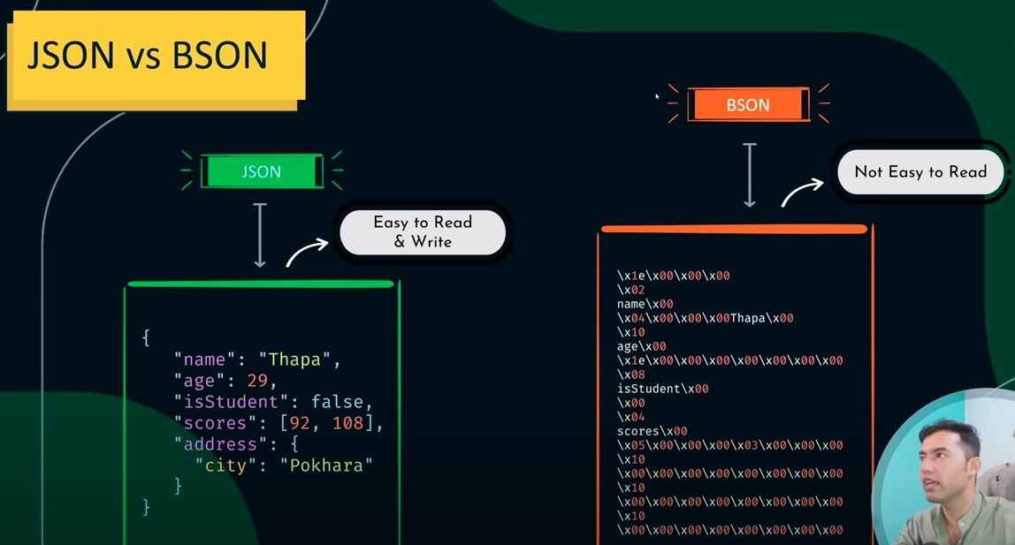

Commands:

1. mongosh: open the terminal
2. show dbs: get all the dbs
3. show collections: get all the collections
4. use db_name: use that db.
5. db.createCollection(“test”): create collection.
6. db.[collection_name].drop(): drop the collection
7. db.dropDatabase(): delete the database
8. db.[collection_name].insertOne({

key: value,

Key1: value1

})

1. db.[collection_name].insertMany([

{

key: value,

Key1: value1

},

{

key: value,

Key1: value1

}

])

1. db.[collectionname].find(): get the record of the collection.





1. db.[collection_name].find({“key”: “Value”});
2. db.[collection_name].findOne({“key”: “Value”});
3. mongoimport jsonfile.json -d [database_name] -c [collection_name]
4. mongoimport jsonfile.json -d [database_name] -c [collection_name] - - jsonArray: JSON Array mango import we need to add –jsonArray.

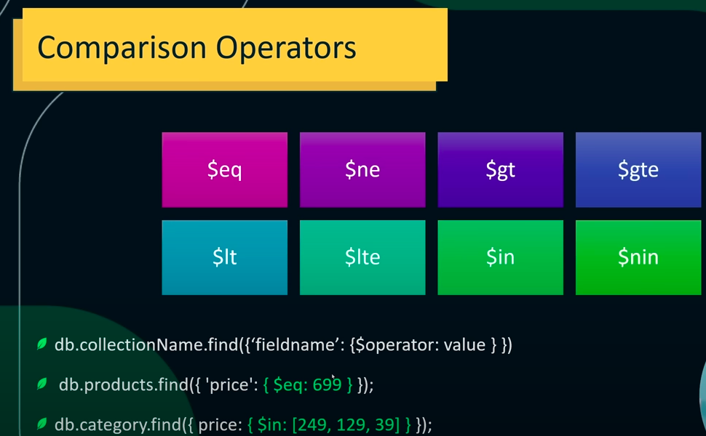

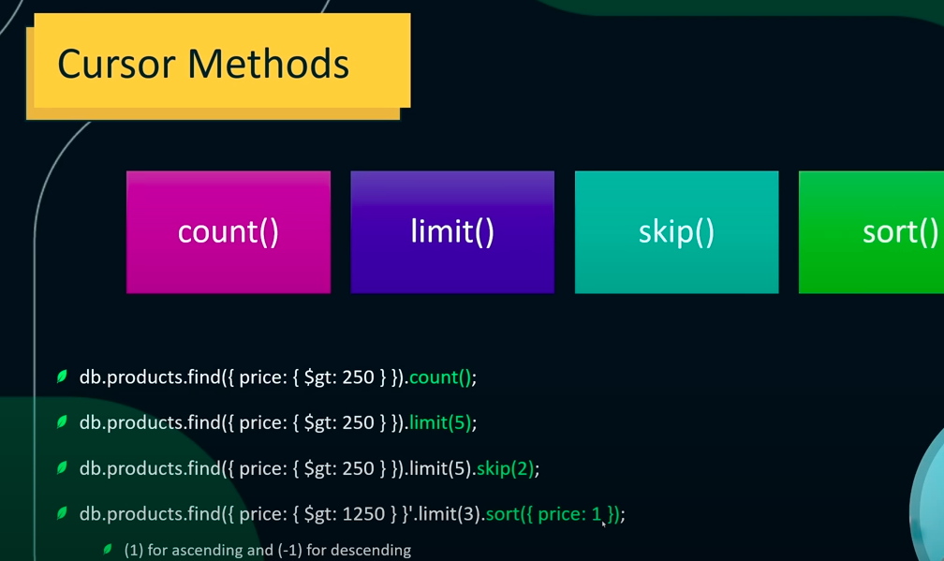

Using Cursor issue:

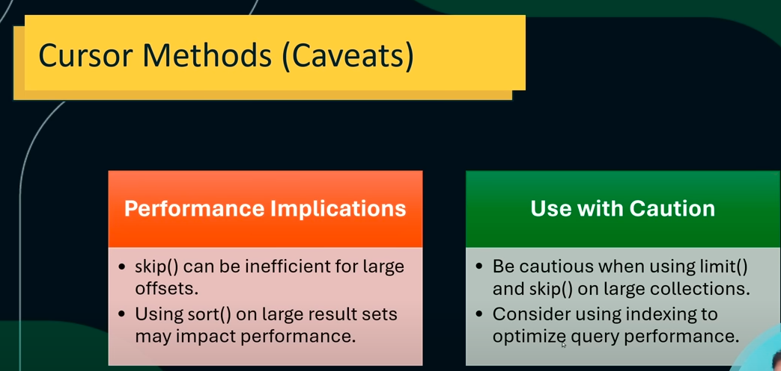

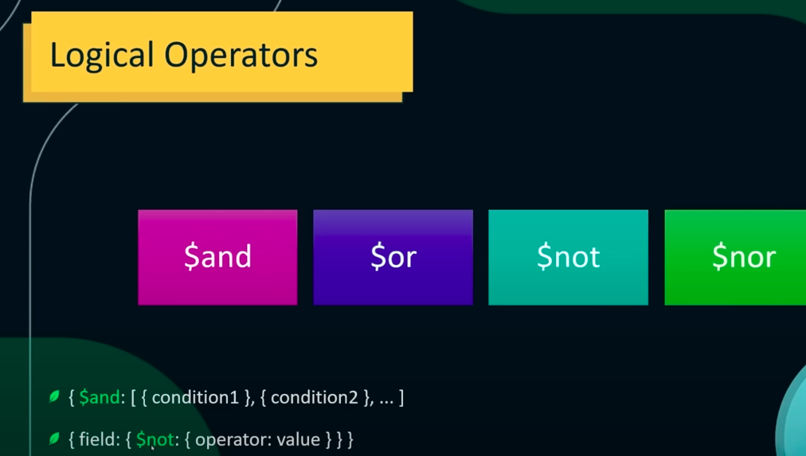



$mul: use instead of the Multiply.

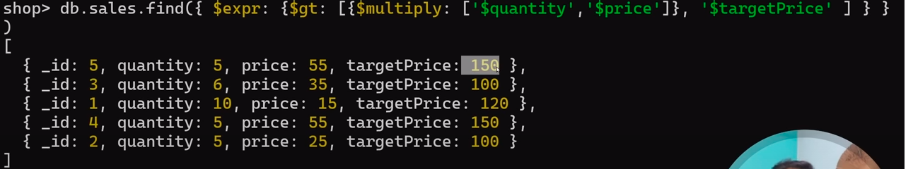

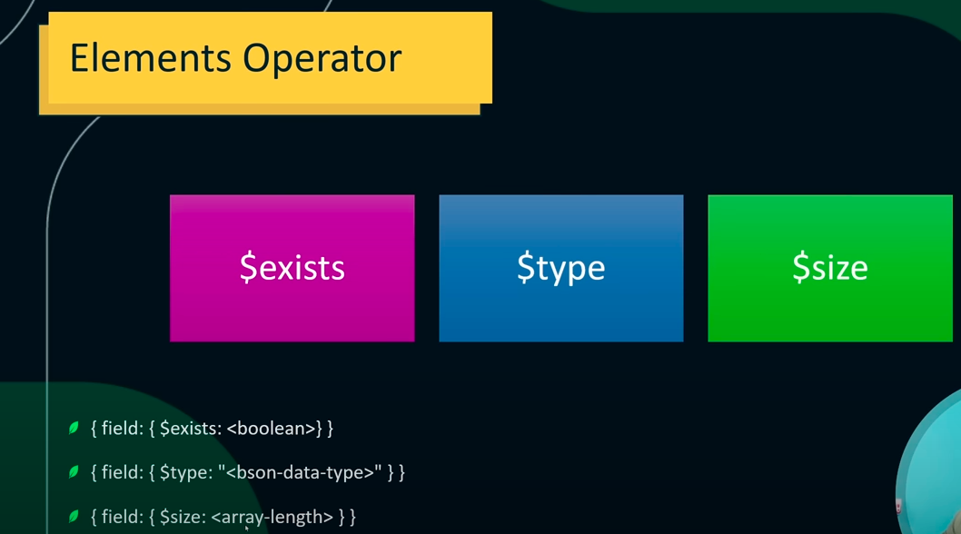

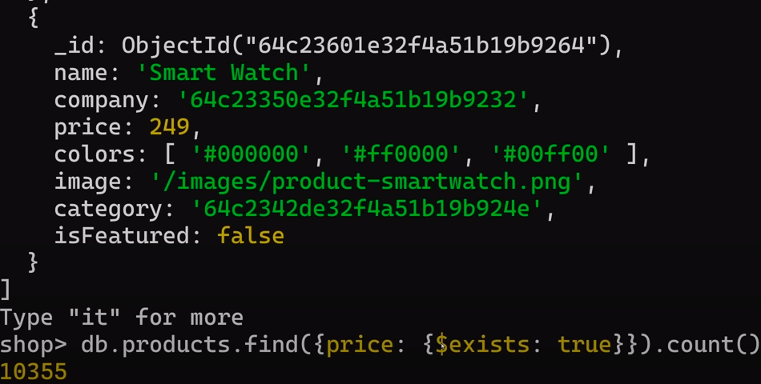



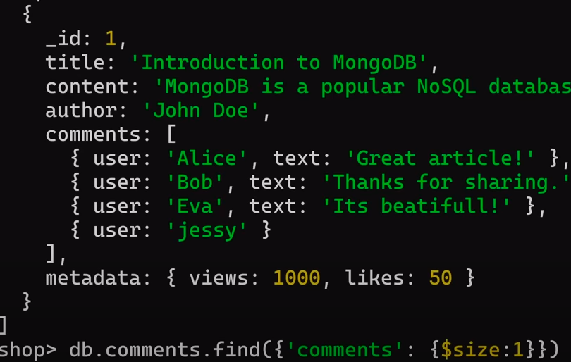

>> no result

shop> db.comments.find({‘comments’: {$size: 4}})

>> it get the records which comments have the 4 objects array.

Projection: which field we need to show or hide for that we use projection.

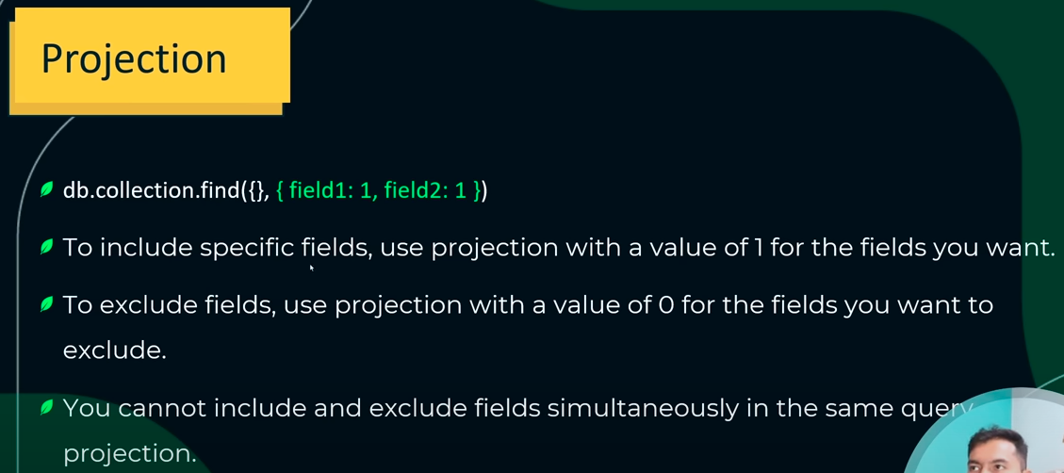



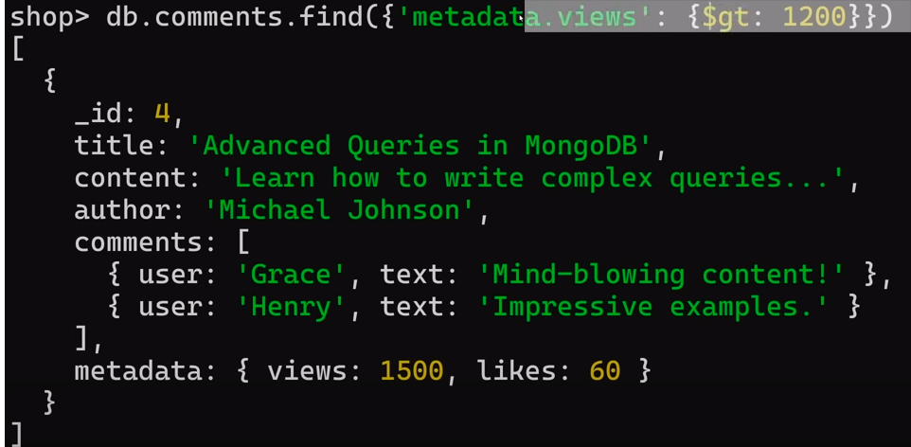

$all and $elemMatch is used with only in the parent child relation.



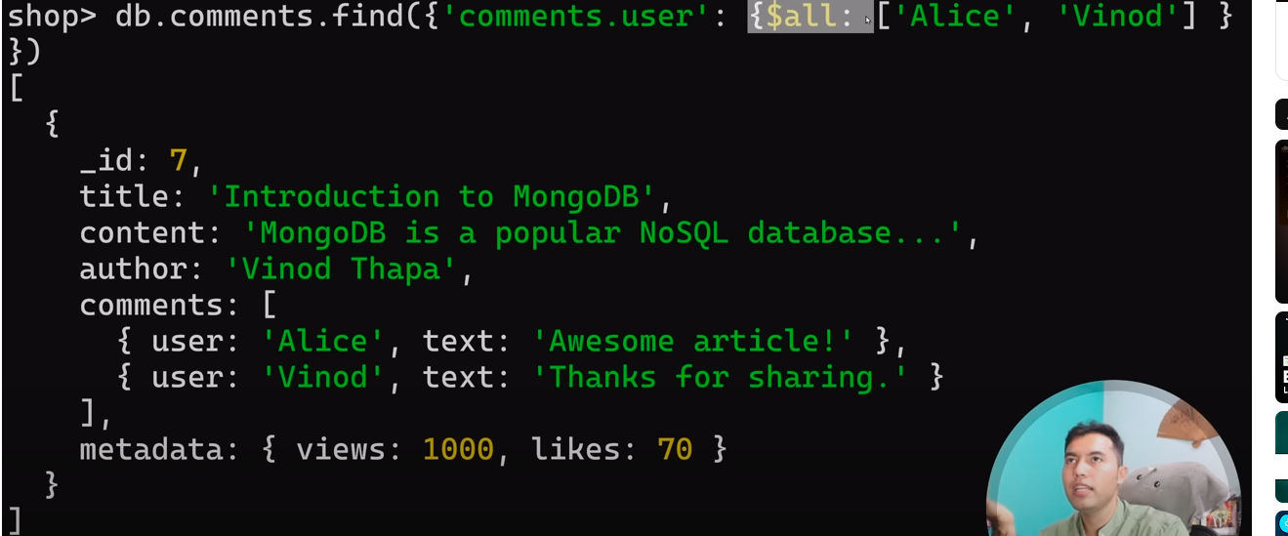

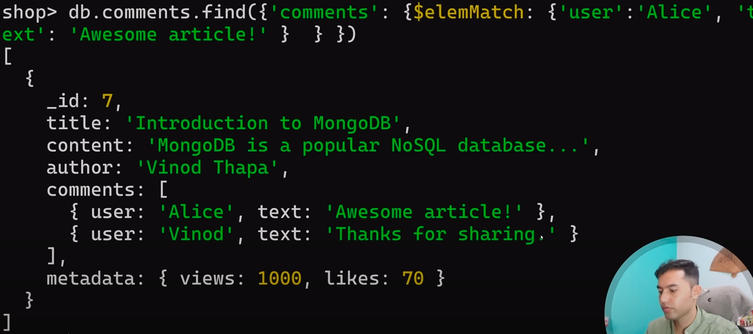

**Update operation in Mongo DB:**



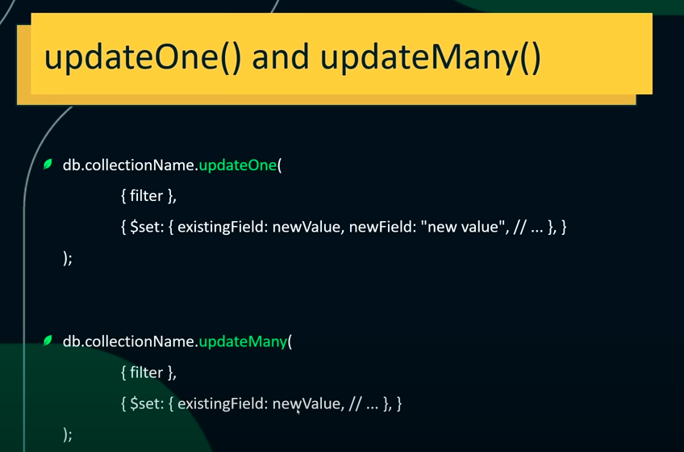

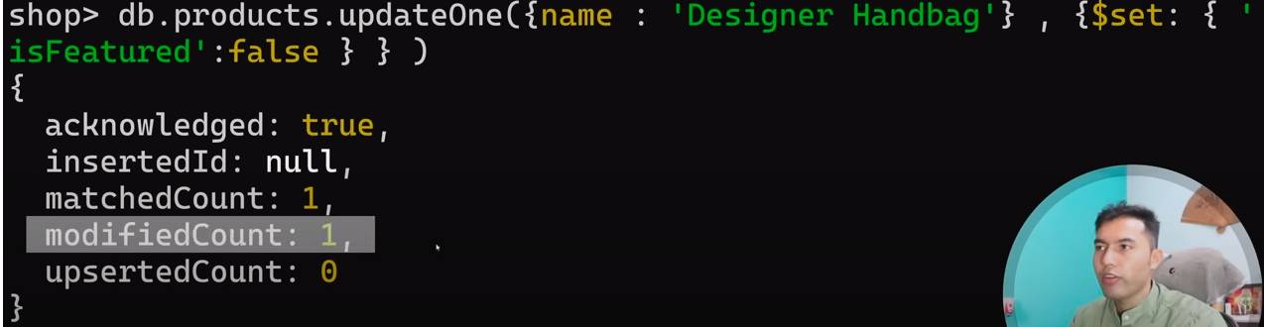

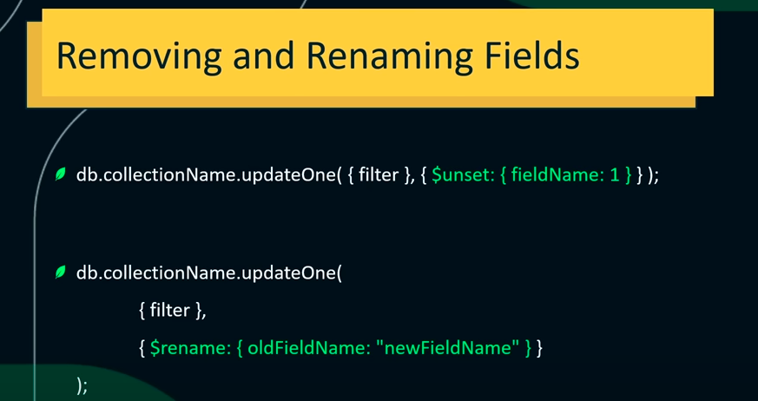

db.test.updateMany({item: {$ne: null}}, {$unset: {status: 1}}) : remove the field

db.test.updateMany({item: {$ne: null}}, {$rename: {instock: "instocked"}}): rename the field

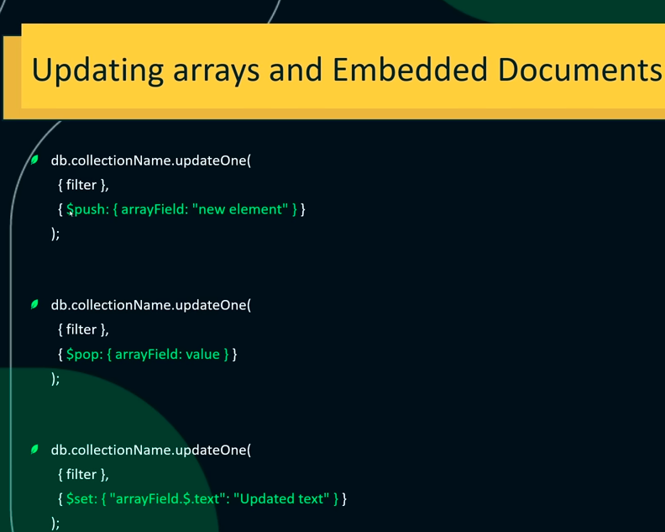

Add new Attribute:

Ex:

{

_id: ObjectId("655af67e218f0e74bfb9f232"),

item: 'postcard',

status: 'A',

size: { h: 10, w: 15.25, uom: 'cm' },

instocked: [ { warehouse: 'B', qty: 15 }, { warehouse: 'C', qty: 35 } ]

}

db.test.updateOne({_id: ObjectId("655af67e218f0e74bfb9f232")}, {**$push**: {instocked: {warehouse: 'A', qty: 50}}})

Change the instocked warehouse value of the array

db.test.updateOne({_id: ObjectId("655af67e218f0e74bfb9f232"), 'instocked.qty': 50}, {$set: {'instocked.$.warehouse': 'AA'}})

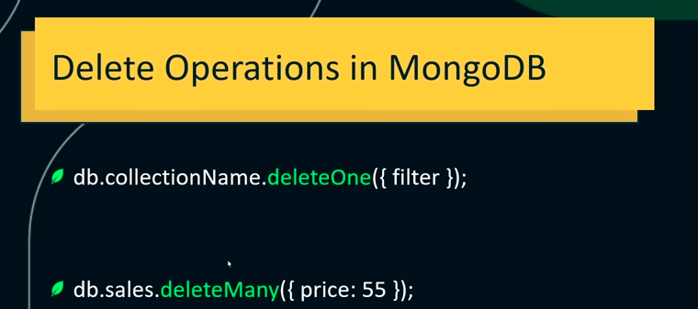

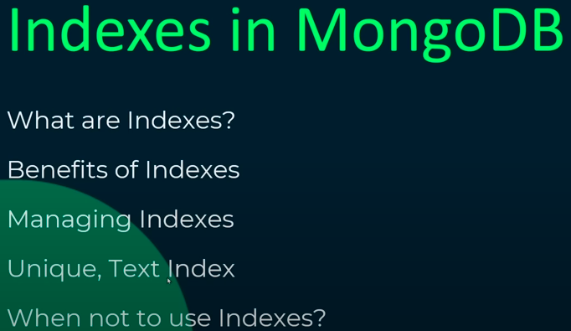



db.test.find({name: ‘test’}).explain();

db.test.find({item: 'test'}).explain("executionStats");

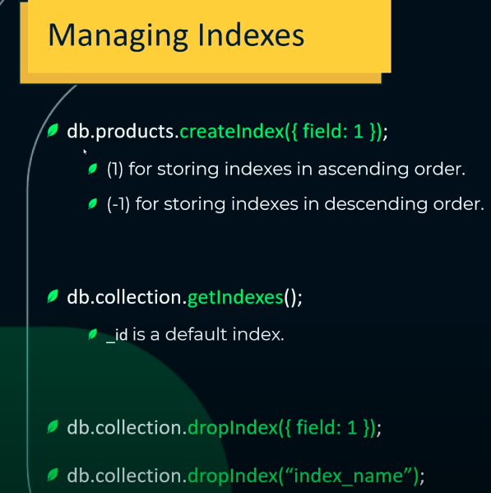



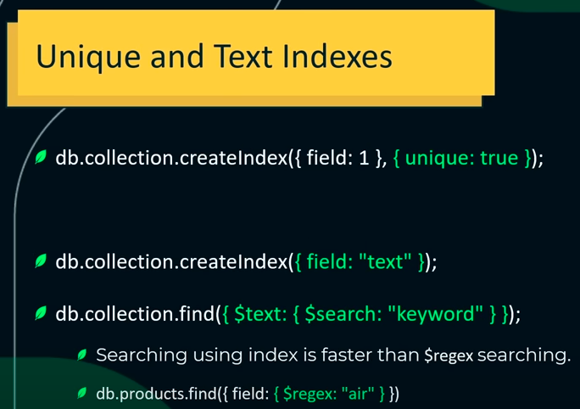

**Aggregation:**



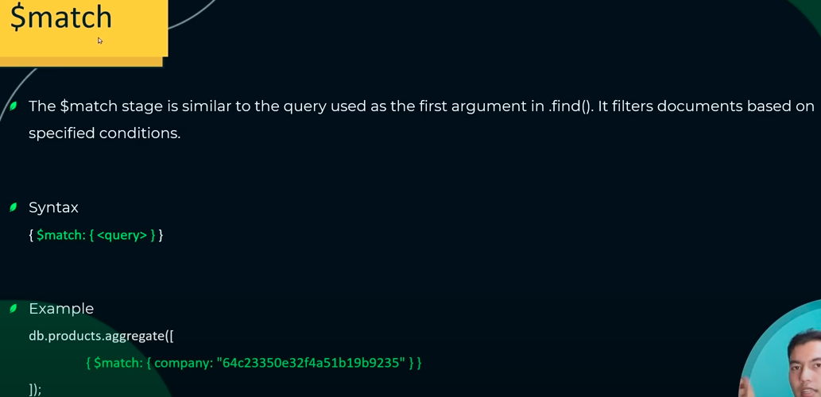

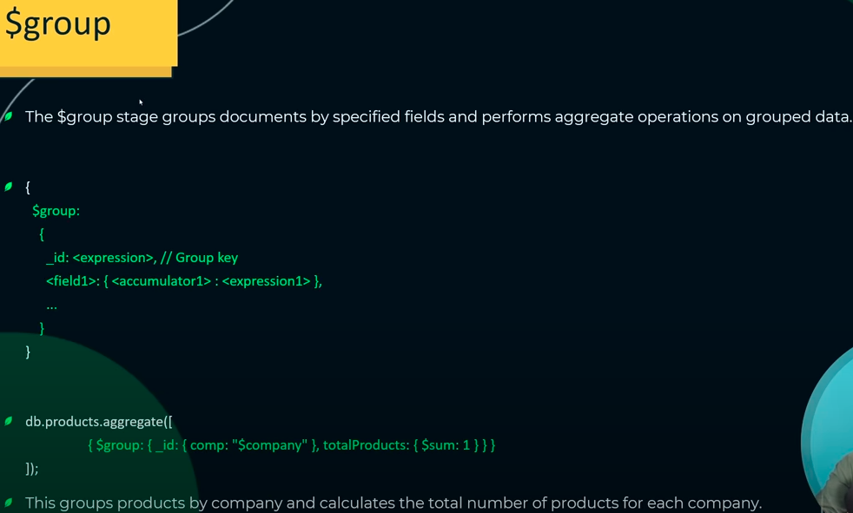

-> Match is the same as the find. Match with the aggregate is use to combine two conditions.

db.test.aggregate([{**$match**: {item: "notebook"}}])

db.test.aggregate([{$match: {"instocked.qty": {$gt: 16}}}])

-> group will use to group the record based on the condition.

db.test.aggregate([{$group: {_id: "$item", totalProducts: {$sum: 1}}}])

-> calculate the number of records with the same item name using the group by and show count

db.test.aggregate([{$group: {_id: "$item", totalProducts: {$sum: 1}}}])

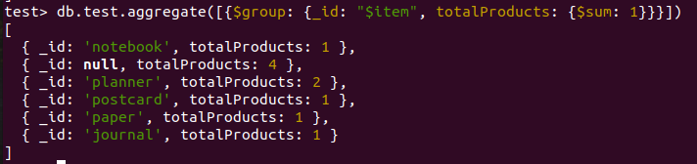

-> calculate the number of records with the same item name using the group by and sum of attributes used in that.

db.test.aggregate([{$group: {_id: "$item", totalProducts: {$sum: $age}}}])

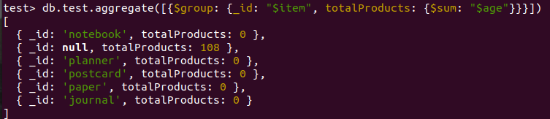

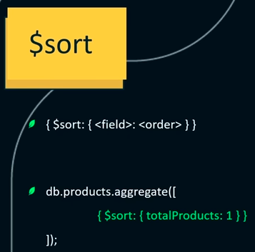

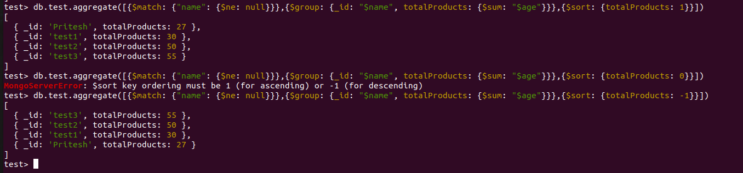

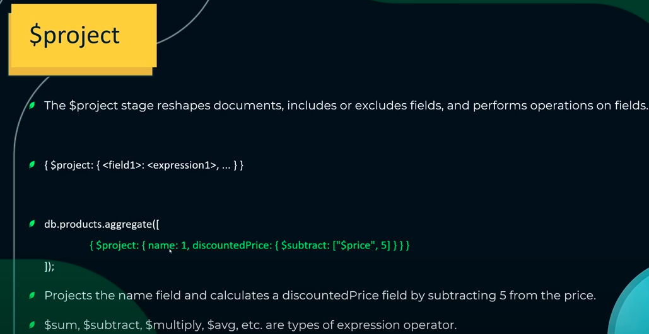

Get only the name and show discount price as a age - 5.

>> db.test.aggregate([{$project: {name:1, totalDiscount: {$subtract: ["$age",5]}}}])

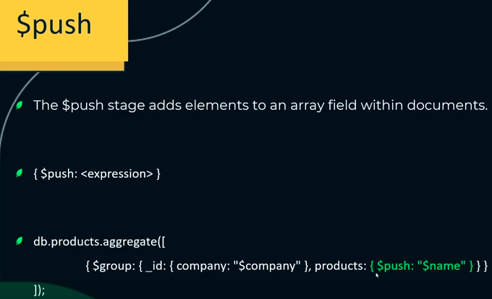

test> db.test.aggregate([{$match: {item: {$ne: null}}},{$group: {_id: "$item", allNames: {$push: "$item"}}}])

[

{ _id: 'journal', allNames: [ 'journal' ] },

{ _id: 'planner', allNames: [ 'planner', 'planner' ] },

{ _id: 'postcard', allNames: [ 'postcard' ] },

{ _id: 'paper', allNames: [ 'paper' ] },

{ _id: 'notebook', allNames: [ 'notebook' ] }

]

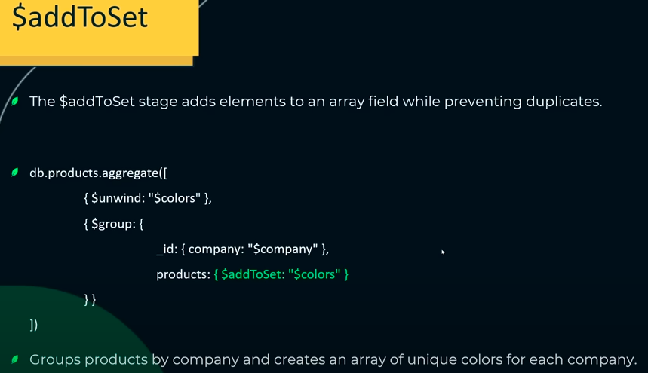

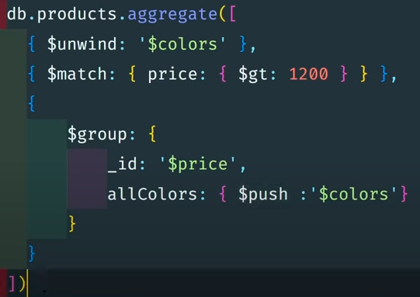

**addToSet**: Is used to remove the duplicate elements.

>> db.test.aggregate([{$match: {item: {$ne: null}}},{$group: {_id: "$item", allNames: {$addToSet: "$item"}}}])

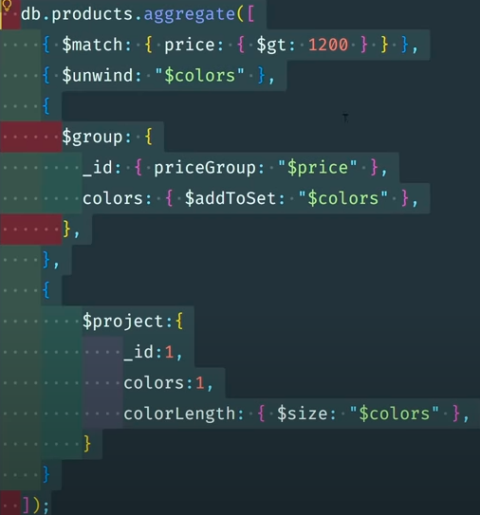

>> db.test.aggregate([{$match: {item: {$ne: null}}},{$group: {_id: "$item", allNames: {$push: "$item"}}},{$project: {item:1, status: 1, instocked: 1,arraySize: {$size: "$allNames"}}}])

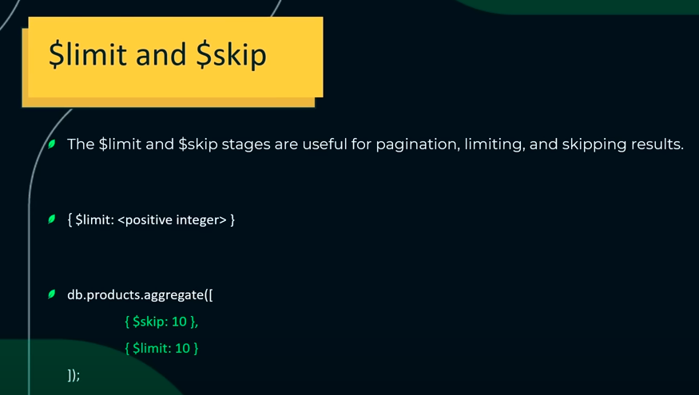

test> db.test.aggregate([{$match: {item: {$ne: null}}},{$group: {_id: "$item", allNames: {$push: "$item"}}},{$project: {item:1, status: 1, instocked: 1,arraySize: {$size: "$allNames"}}},{$limit: 1}])

[ { _id: 'journal', arraySize: 1 } ]

test> db.test.aggregate([{$match: {item: {$ne: null}}},{$group: {_id: "$item", allNames: {$push: "$item"}}},{$project: {item:1, status: 1, instocked: 1,arraySize: {$size: "$allNames"}}},{$skip: 1}])

[

{ _id: 'planner', arraySize: 2 },

{ _id: 'postcard', arraySize: 1 },

{ _id: 'paper', arraySize: 1 },

{ _id: 'notebook', arraySize: 1 }

]

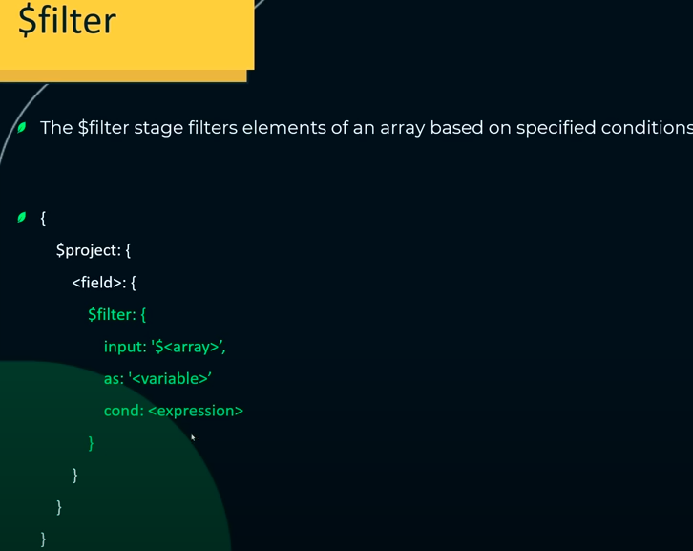

test> db.test.aggregate([{$project: { instocked: { $filter: { input: "$warehouse", as: "warehouse", cond: {$gt: ["$instocked.qty", 2]}}}}}])

[

{ _id: ObjectId("655711ba04f6157d0daeca68"), instocked: null },

{ _id: ObjectId("655711f004f6157d0daeca69"), instocked: null },

{ _id: ObjectId("655711f004f6157d0daeca6a"), instocked: null },

{ _id: ObjectId("655711f004f6157d0daeca6b"), instocked: null },

{ _id: ObjectId("655af67e218f0e74bfb9f22e"), instocked: null },

{ _id: ObjectId("655af67e218f0e74bfb9f22f"), instocked: null },

{ _id: ObjectId("655af67e218f0e74bfb9f230"), instocked: null },

{ _id: ObjectId("655af67e218f0e74bfb9f231"), instocked: null },

{ _id: ObjectId("655af67e218f0e74bfb9f232"), instocked: null },

{ _id: ObjectId("655b58bf044e772380ee3a9d"), instocked: null }

]

**Input:**

test> db.col.find()

[

{

_id: ObjectId("655d9cb6044e772380ee3a9e"),

name: 'Document 1',

values: [ 10, 20, 30, 40, 50 ]

},

{

_id: ObjectId("655d9cb6044e772380ee3a9f"),

name: 'Document 2',

values: [ 15, 25, 35, 45, 55 ]

},

{

_id: ObjectId("655d9cb6044e772380ee3aa0"),

name: 'Document 3',

values: [ 5, 15, 25, 35, 45 ]

},

{

_id: ObjectId("655d9cb6044e772380ee3aa1"),

name: 'Document 4',

values: [ 30, 40, 50, 60, 70 ]

},

{

_id: ObjectId("655d9cb6044e772380ee3aa2"),

name: 'Document 5',

values: [ 25, 35, 45, 55, 65 ]

}

]

test> db.col.aggregate([{$project: {name: 1, value: { $filter: { input: "$values", as: "value", cond: {$gt: ["$$value", 30]}}}}}])

**Output:**

[

{

_id: ObjectId("655d9cb6044e772380ee3a9e"),

name: 'Document 1',

value: [ 40, 50 ]

},

{

_id: ObjectId("655d9cb6044e772380ee3a9f"),

name: 'Document 2',

value: [ 35, 45, 55 ]

},

{

_id: ObjectId("655d9cb6044e772380ee3aa0"),

name: 'Document 3',

value: [ 35, 45 ]

},

{

_id: ObjectId("655d9cb6044e772380ee3aa1"),

name: 'Document 4',

value: [ 40, 50, 60, 70 ]

},

{

_id: ObjectId("655d9cb6044e772380ee3aa2"),

name: 'Document 5',

value: [ 35, 45, 55, 65 ]

}

]

**Mongo Db using the Docker**

